**Face Mask Detection**

*Rohith Reddy Bollareddy, Brijesh Rao Pamara, Blessy Kuriakose, Amrutha Veeramachaneni*

**Introduction**

The motive of this project is to encourage mask usage by bringing attention to whether a mask is present on one's face or not. (This is under the same principle as the use of speed monitoring displays to encourage drivers to reduce their speed in select locations.) The goal is to report this information to those to whom this is a concern, which, for the present purposes of this project, will be the individual themselves. The significance is in the present condition with the pandemic: Mask usage is an important step in protecting ourselves and each other from the spread of the virus. The objective is to have more people use masks in the setting of implementation.

This program will first detect a face using a basic cv2 algorithm. A cropped image of this face will then be provided to a model which will extract certain features to determine if a mask is present or not. The features will be extracted via HOG and sift, spatial features, and features acquired through Gaber. These will be used to detect the face and analyze contours, alongside other needed processes.

**Related Work (Background)**

There are multiple implementations of face mask detection that are referenced in the literature. One literature is the “Review on Literature Survey of Human Recognition with Face Mask.” This one turns its attention to recognizing faces while a face mask is present, however many of its methods for face and mask detection remain relevant to our project. It refers to multiple methods of evaluation/feature extraction such as sift and Hog, as well as some novel variants. It also contains references to other texts that take to a simple mask detection model.

**Dataset**

There are several datasets available; below are links to a few sources:

<https://github.com/balajisrinivas/Face-Mask-Detection,>

<https://github.com/cabani/MaskedFace-Net>

**Detail design of Features**

We will design this using any of three features such as HOG, spatial, swift, SIFT etc. Currently the code is only set to extract HOG feature-descriptors from the live-source image.

**Analysis**

So far, we have only completed the face detection part of the pipeline. The output from this portion is similar to the images available in the first dataset. Which makes a more hopeful case for training the main classification model on preexisting data, opposed to having to go and create new ones.

**Implementation**

Our plan for implementation is as follow:

1. Data Augmentation
2. Extract Features
3. Split the data into train and test
4. Train CNN, LSTM and test them to get the best accurate model.

**Preliminary Results**

We have implemented a way to capture a cropped image of a face from a live camera feed. (See **Figure 1**, below.) To be exact –the image is first captured from the live-video and then cropped for further implementation. We have noticed that the face detection shows more errors when the mask is on (opposed to when it is off). (See **Figure 2**, below.) From testing we found that having the camera angled from a higher position makes for more accurate cropping to the face.

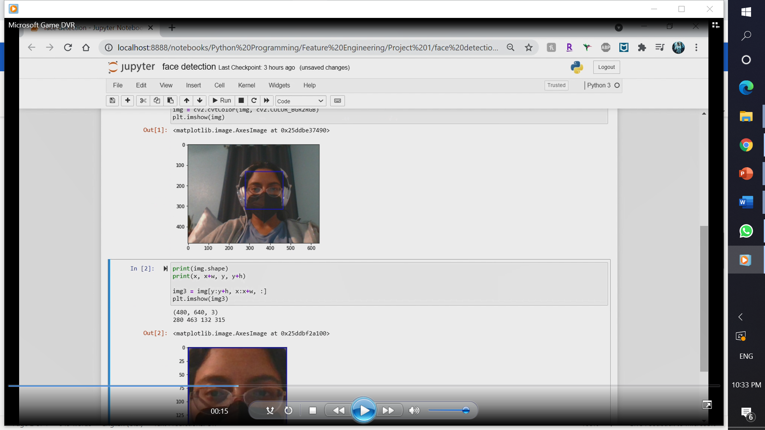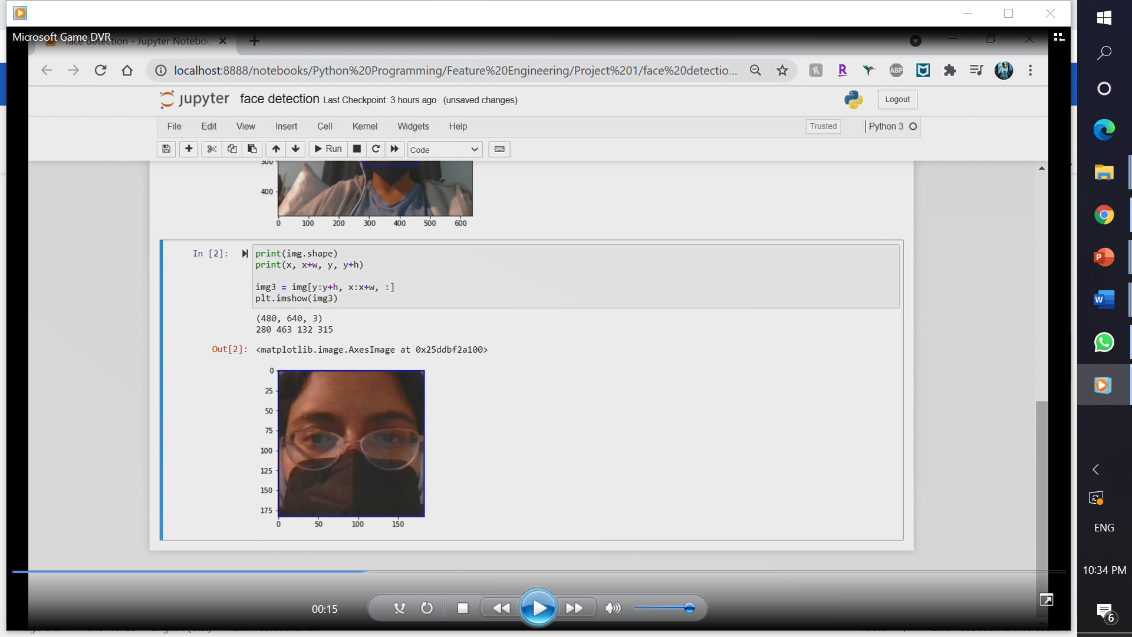

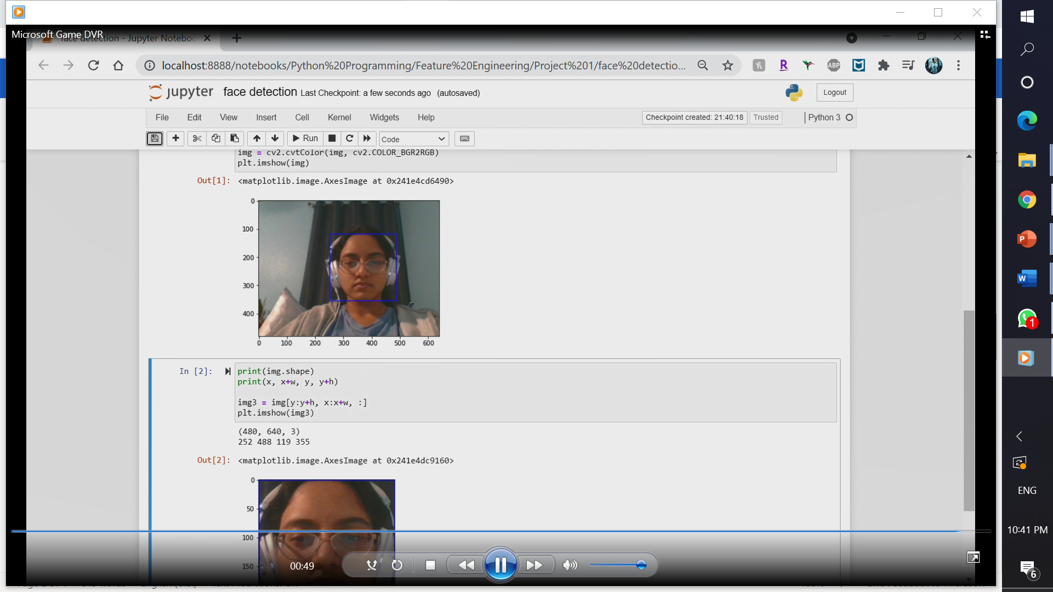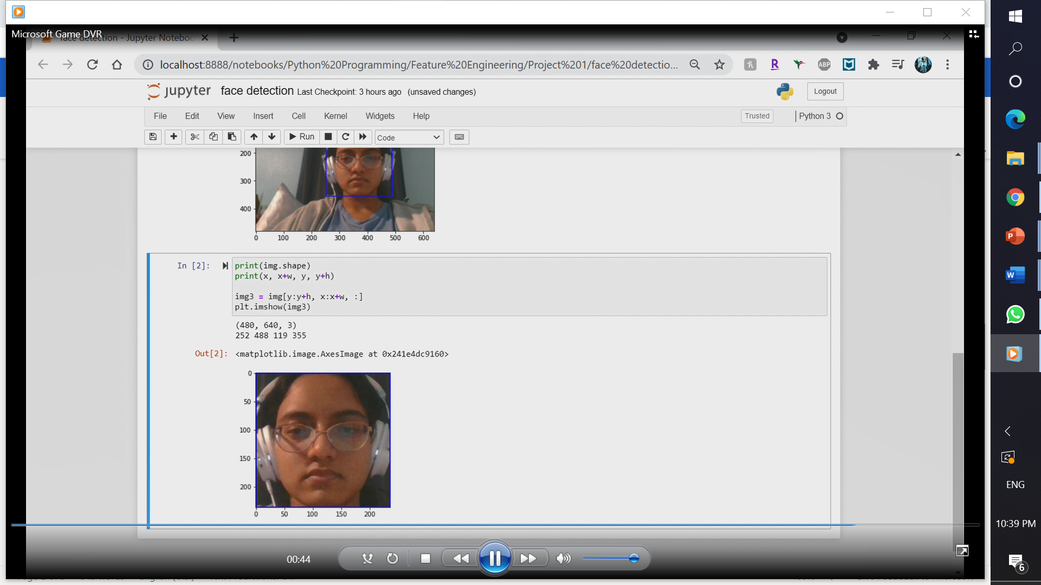

***Figure 1: Face detection (left) and cropping (right) with (top) and without (bottom) mask.***

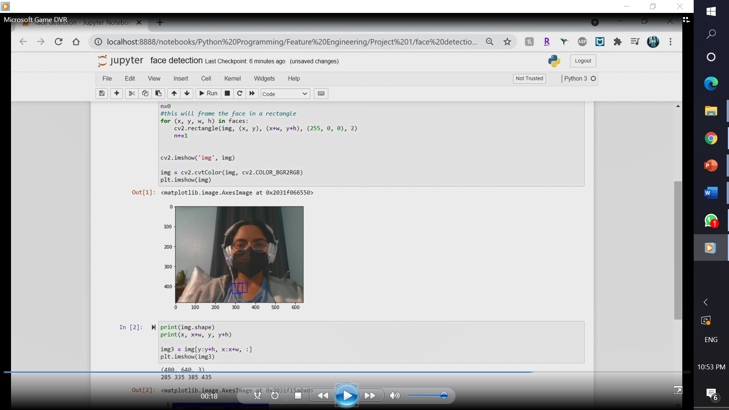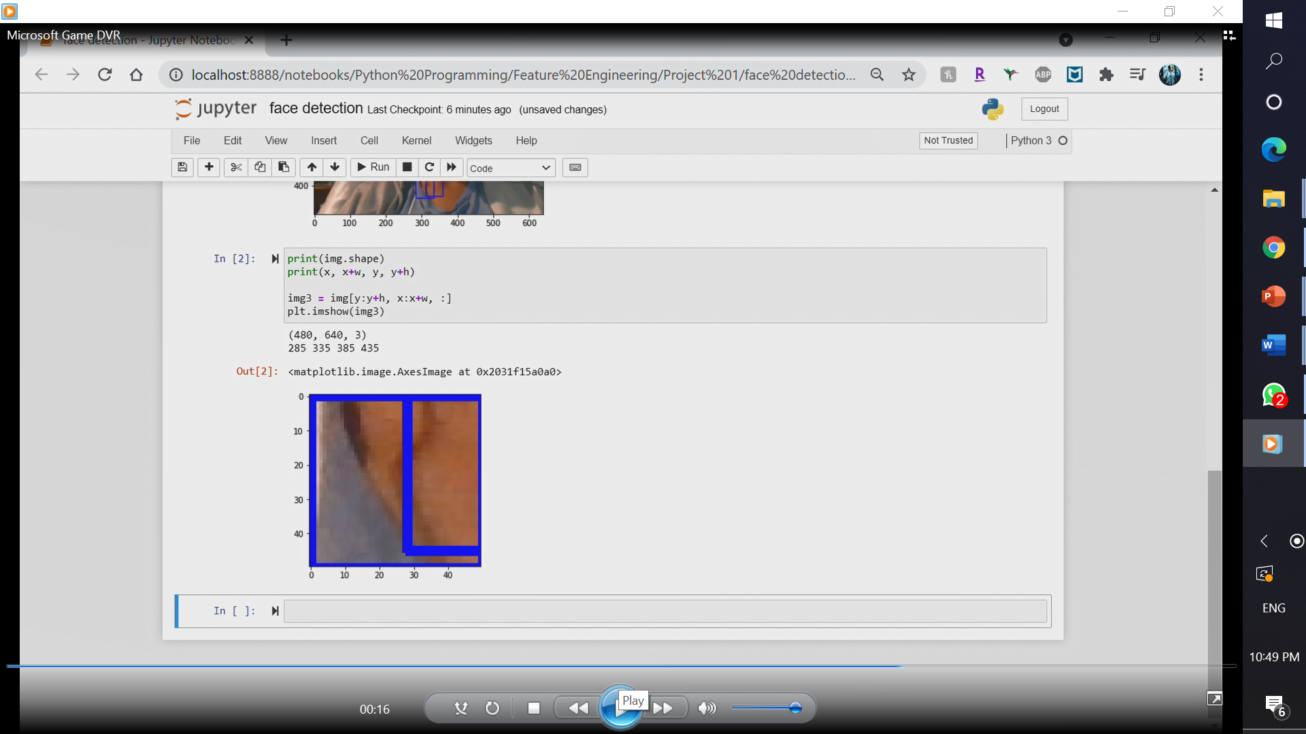

***Figure 2: Failed detection with mask on.*** *Note that there are multiple lines visible here as multiple ‘faces’ are detected.*

**Project Management**

Objectives in code implementation include:

1. Identifying the faces within the image.
2. Assessing if the face is wearing a mask.
3. Assessing how the face mask is being worn (if time permits).
4. Giving a visual ‘warning’ or ‘okay’ to a screen, which, in practice, would be visible to the individual being assessed.

Implementation status report

***Work completed***

* Research on prior implementations for use as guides; Rohith
* Code for basic face detection and cropping; (found and reformatted by) Blessy
* Some possible datasets for training; Blessy, Rohith

***Work to be completed***

* Finding external datasets that can be used to train a model.
* Training a model for mask detection with like images/videos.
* Areas of concern:
  + We are not certain about the feasibility of training a model with features that are manually extracted, opposed to descriptors extracted by an imported module, or maybe merging the two with relevant weights.
  + We are aiming to make a model that can work with live data from a camera, however the datasets we find may have their own distinguishers or settings that might not be proper for this task. We will only know the effect of this change after completing the implementation, at which point there is a chance that we would have to make changes to the project for the turn in.
  + The face detection module we are using is not always accurate, especially with a mask on. We plan to position the camera at a higher angle, which does reduce this problem while also mocking how a real monitoring-camera would capture video –from a higher position than the subject.

***(GitHub Link:*** [***https://github.com/trela47/Face-Mask-Detection.git***](https://github.com/trela47/Face-Mask-Detection.git)***)***

**References**

W. Sandberg, T. Schoenecker, K. Sebastian, and D. Soler. “Long-Term Effectiveness of Dynamic Speed Monitoring Displays (DSMD) for Speed Management at Speed Limit Transitions.” 2006 ITE Annual Meeting and Exhibit Compendium of Technical Papers

Casey, S. M. and A.K. Lund. “The Effects of Mobile Roadside Speedometers on Traffic Speeds.” Accident Analysis and Prevention, Vol. 25, 1993, pp. 627-634

Dr. V. S. Bhat, A. D. Shambavi, K. Mainalli, K. M. Manushree, and S. V. Lakamapur. “Review on Literature Survey of Human Recognition with Face Mask.” International Journal of Engineering Research & Technology (IJERT), Vol. 10 Issue 01, 2021